Something to Explore This Week
An Experiential Ministry By: Becky Lynch

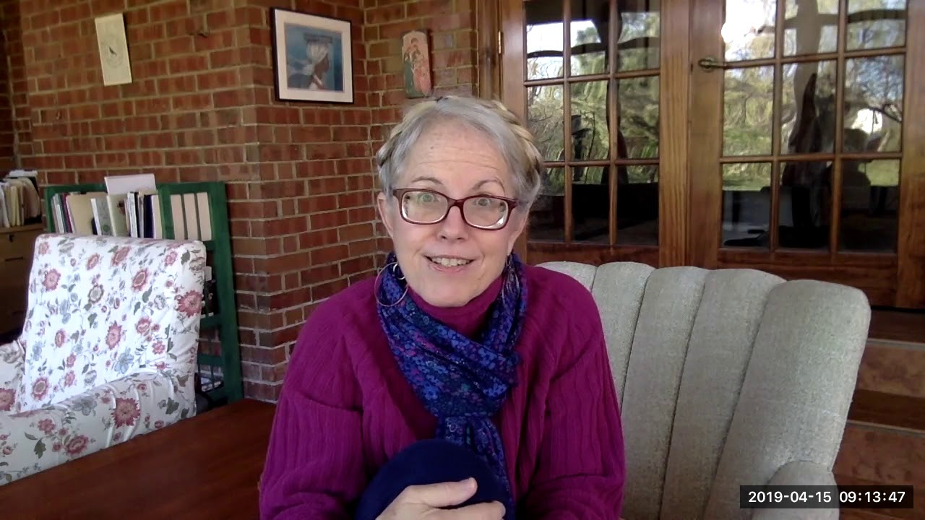
Use The Awakened Life meditations and links below as your week-by-week guide for each stage of the curriculum.

Abundant Life

This is a curriculum by: The General Board of Ministry from the United Methodist Church

1st Meditation

Thoughts on Trees:

Trees are beautiful, bountiful, and essential. Their benevolent presence is both a necessity and an intangible gift; we need the oxygen they produce, and we benefit from their steadfast, magnanimous presence in other ways, too.
Spending time with our tall green neighbors can reduce stress levels, return us to the present moment, and bring a sense of peace and quiet into our busy modern lives. In Japan, there’s even a name for the practice of energetically cleansing and grounding oneself by walking in the woods: shinrin-yoku, or forest bathing.
Trees also filter our ground water and purify the air, while providing habitats for many species, beautifying communities, and cooling summer streets. They even store carbon and provide food, and all they ask in return is space to grow so they can offer their many gifts.
People who love trees can find solace among their quiet leafy friends most anywhere in the world.
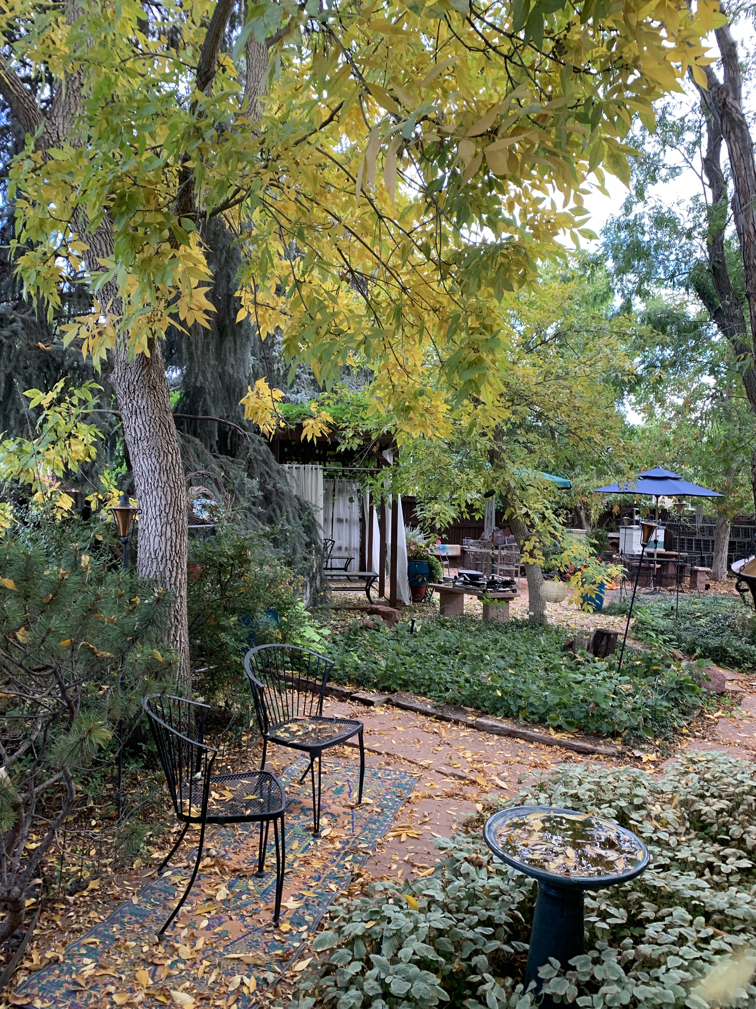

It is not so much for its beauty that the forest makes a claim upon men's hearts, as for that subtle something, that quality of air that emanates from old trees, that so wonderfully changes and renews a weary spirit.
— Robert Louis Stevenson

The best time to plant a tree was 20 years ago, the second best time is today.
— Ancient Chinese proverb

Thoughts from Books:

- Quiet: The Power of Introverts in a World That Can't Stop Talking. “There’s zero correlation between being the best talker and having the best ideas.” By: Susan Cain

Susan Cain is the author of the best-selling book “Quiet: The Power of Introverts in a World That Can't Stop Talking.” In her TED Talk, she extols the undervalued gifts of quiet and introspective people, and explains how introversion is different from shyness.

2. The End of Bias: A Beginning.
The science and practice of overcoming unconscious bias. By: Jessica Nordell
Notes By: Karen Bueno, member of the GSUMC Diversity Team

Prejudice is a habit that can be broken:
1. Notice your own bias or stereotype.
2. Utilize Mindfulness. (Make reality impossible to ignore by using mindfulness)
3. Cultivate awareness, attention, and non-judgment.
4. Choose helpful behavior.
5. Grapple with the pain of our history.
6. Erase indifference to others’ past and present pain.
Shame may be a stress response turned inward. (Compassion is shame’s antidote.)
RAIN: Recognize bias in own thoughts and feelings.
Allow, rather than deny or avoid
Investigate why I feel that way.
Nurture the difficult feelings with compassion in order to transform them
P. 271-- To change unconscious, unintentional or unexamined bias requires
- The will to change
- Great effort
- Knowledge about reality
Individual bias change will NOT become societal change. Only large systemic change can reduce injustices. As you work toward ending your own bias, you will make mistakes in what you do and say. The key is to PERSIST after you have made a misstep.
Seeking diversity in a business fails when the motivation is the number of BIPOC on the staff. It succeeds when the motivation is that different skills and viewpoints are considered crucial.
The organization needs to: fully integrate, be open to change as an organization, see value in unique contributions,regard differences as riches.

The CDC added mental health disorders to the list of primarily physical conditions that increase the risk of Covid-19 hospitalization or death.

Earlier this month, the Centers for Disease Control and Prevention (CDC) added mood disorders to the list of conditions that put people at high risk for severe Covid-19. Millions of Americans with conditions "including depression and schizophrenia spectrum disorders” are eligible for booster shots based on their mental health diagnosis alone.
The decision comes after mounting evidence that mental health conditions make individuals of any age more likely to become severely ill from Covid-19. A meta-analysis published this month in JAMA Psychiatry found a link between mood disorders and the risk of hospitalization and death from Covid-19, according to Lauren Frias for Insider. A study from January of this year found that Covid patients with schizophrenia were nearly three times more likely to die from the virus, though those with mood and anxiety disorders were not at an increased risk of death from coronavirus infection. A 2020 study from the Lancet Psychiatry was another to suggest that “a psychiatric diagnosis might be an independent risk factor.
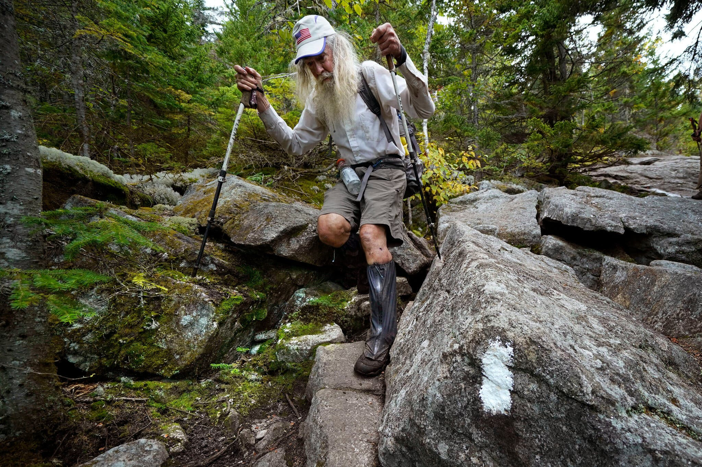 Appalachian Trail Conservancy
“M.J. Eberhart, 83, is the oldest known person to hike the entire Appalachian Trail. “Eighty percent of it is mental grit,” he said. “And that is why so many people fail.”
M.J. Eberhart, an 83-year-old retired eye doctor, had a strenuous weekend.
On Sunday, he pushed through the final few miles of a hike on the Appalachian Trail, becoming the oldest known person to complete the roughly 2,190-mile trail from Georgia to Maine.
It was an odyssey that started in January from his home in Flagg Mountain, Ala., with a series of day hikes that gradually took him to Georgia. From there, he started the journey along the Appalachian Trail. He carried a six-pound pack, with a tent, sleeping bag and other gear (not including food and water).
By July, he was on the New York-Connecticut state line when a friend took him off the trail and drove him to Maine to avoid bad weather. From there, he hiked south
“Once you get into it, it helps steel you,” he said. “The more you get into it, the more committed you have to be. The trek requires mental, as well as physical, resolve. Eighty percent of it is mental grit,” Mr. Eberhart said. “And that is why so many people fail.”
Known by his trail name “Nimblewill Nomad,” Mr. Eberhart hiked the distance in segments. Sometimes friends and supporters hiked with him or picked him up for overnight breaks of a warm bed and meal, driving him back the next morning to where he had dropped off the trail.

Mostly, he slept in the wild. He was stunned by the natural beauty around him. He saw bears. Mosquitoes dive bombed and pecked at him. He dreaded the prospect of boulders and 50 mile-an-hour winds in the Presidential Range in New Hampshire.

And he came “face to face” with himself, he said in an interview. Every day, he said, he overcame the temptation to quit. “I knew what was coming,” he said. “And day to day, the challenge.” But he pushed on. At the end, Mr. Eberhart hiked the last leg of his trek on Sunday into Dalton, Mass., and into the record books

5 Ways to Show Your Pet You Appreciate Them
Our pets do a lot for us! Not only are they our fur children, but they’re also our therapists, best friends, cuddle partners and the list can go on forever. To show our appreciation for pets, we came up with five ways pet parents can spoil them.

- Make a treat – food is often the way to your pet’s heart. Homemade treats can be a delicious and nutritious way to show them some extra love.
- Let them pick a toy from the pet store– a trip to the pet store might be a fun activity all on its own. But letting your pet sniff out their next favorite toy will take the experience to a new level!
- Check into a pet-friendly hotel – if you’re looking to splurge a little, consider checking into a pet-friendly hotel near home or in a new city (bonus points if it’s near a great pet-friendly walking trail).
- Schedule a neighborhood walk with your pet pals– social time is a fun time. Check-in with your other pet-owning pals and get a group together for a walk in the neighborhood or a group trip to the dog park.
- Build an obstacle course in the backyard – give your pet a backyard they’ll love with a DIY obstacle course built just for them It may be exactly the treat your pet has been longing for.

Animal Therapy
Examine the craze behind goat yoga and cow cuddling, plus the benefits of foster kittens in care communities.
Idioms and Proverbs

Every culture has its share of idioms and proverbs, messages that help to illuminate truths about their beliefs, customs, and ways of being. Technically speaking, a proverb is a short and pithy saying that gets at an elemental piece of advice (“Don’t cry over spilled milk”), whereas an idiom is a turn of phrase that uses a figure of speech to make a specific point (“They rubbed me the wrong way”). Japanese culture is rife with wisdom imparted in both forms; in fact, in Japan, proverbs are known as kotowaza, a term that was used in ancient Japan to refer to words conveyed by deities through oracles. Proverbs hold a particularly significant place within Japanese culture — they are thought to be wisdom passed down from the ancestors.
It’s worth noting that although there are many English phrases that can be used as rough translations for Japanese idioms and proverbs, there is often no direct equivalent, given that these aphorisms are so contextually and culturally dependent. For instance, the Japanese proverb “Nen ni wa nen o ireyo” has been translated into “Look before you leap,” but a more literal translation of the phrase is “Put care into care,” which is a considerably different sentiment than the English translation. All the same, part of the joy of learning proverbs and idioms from other cultures is getting to understand language and seeing life lessons in a new light. Here is 1 wise Japanese saying that offer up a small but important everyday reminder.

二兎を追う者は一兎をも得ず
(Nito wo ou mono wa itto mo ezu)
A man who chases two rabbits doesn’t deserve one.

The closest equivalent proverb in English is “A bird in the hand is worth two in the bush.” In other words, it is best to focus on just one thing at a time, rather than have your attention scattered in multiple directions.

‘Like a Scene Out of ‘Arachnophobia,” Invasive Spiders Take Over Northern Georgia. Rasha Aridi
Scientists are torn on whether the Joro spider could have positive or negative effects on the native ecosystem
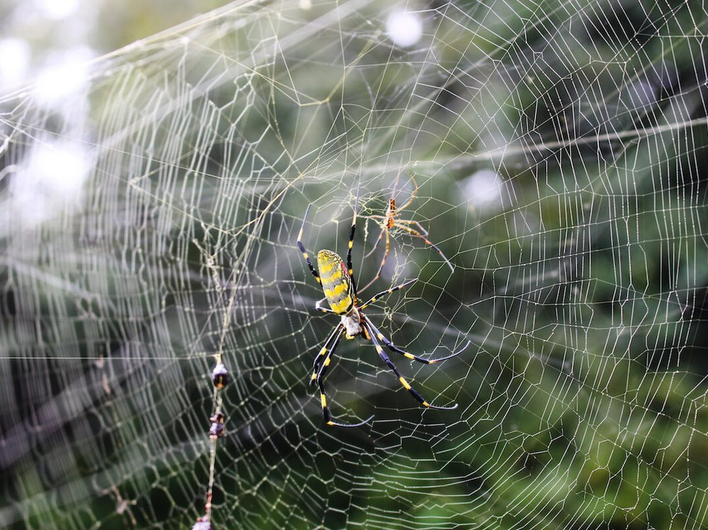The Joro spider—Trichonephila clavate—is a colorful species native to Korea, China, Taiwan and Japan. It was first identified in Georgia in 2014, after likely hitching a ride on a shipping container and ending up on I-85 in Georgia, reports Ben Turner for Live Science.

The three-inch Joros can weave their massive webs almost anywhere, including porches, gardens and mailboxes.Imagine waking up on a beautiful, brisk fall morning. You take a step onto your porch, but instead of taking in the crisp autumn air and admiring the colorful foliage…you end up entangled in a sticky, ten-foot spider web.

That's the reality for some folks living in northern Georgia, where a spider native to east Asia has taken a foothold and left residents bugging out, reports Sudhin Thanawala for the Associated Press (AP). The Joro spider—Trichonephila clavate—is a colorful species native to Korea, China, Taiwan and Japan. It was first identified in Georgia in 2014, after likely hitching a ride on a shipping container and ending up on I-85 in Georgia, reports Ben Turner for Live Science.
"Last year, there were dozens of spiders [on my property], and they began to be something of a nuisance when I was doing yard work," Will Hudson, an entomologist at the University of Georgia, says in the press release. "This year, I have several hundred, and they actually make the place look spooky with all the messy webs—like a scene out of ‘Arachnophobia.” Despite hanging out in Georgia for years, the spiders only emerged in massive numbers recently. Millions have been detected across 25 counties in Georgia, according to a press release.
"We see natural ebbs and flows in the populations of many different species that may be linked to local conditions, particularly slight changes in rainfall," Paula Cushing, an arachnologist at the Denver Museum of Nature and Science, tells the AP.
Joro spiders have taken over Hudson's porch, making it unusable, and he's had to kill more than 300 females on his property so far this year, Live Science reports. "The webs are a real mess. Nobody wants to come out of the door in the morning, walk down the steps and get a face full of spider web," Hudson says in the press release. "They are gorgeous spiders, but there are just too damn many of them."
Invasive species—like spotted lanternflies, feral hogs and giant lizards called tegus—are notorious for wreaking havoc on native habitats and outcompeting wildlife, but scientists don't know enough about these leggy critters to definitively say whether or not they'll be harmful, Adam Gabbatt reports for the Guardian.
Nancy Hinkle, an entomologist at the University of Georgia, is hopeful. Joros eat pesky mosquitoes, flies and even brown marmorated stink bugs—a destructive species for crops. Plus, they aren't harmful to humans or pets. "Joro spiders present us with excellent opportunities to suppress pests naturally, without chemicals, so I’m trying to convince people that having zillions of large spiders and their webs around is a good thing," she says in the press release.
Other scientists aren't so sure. Ann Rypstra, a spider ecologist at Miami University, says more research is needed. "I’d always err on the side of caution when you have something that establishes itself where it’s not supposed to be," she tells the AP.
Joro spiders will likely die off by the end of November as the weather cools, but experts are expecting them to make a grand reappearance next year. Female Joros will lay their egg sacs—each containing more than 400 spiderlings—soon, and the hatchlings will emerge in the spring. Then, the wind will wisp them away on a strand of silk, carrying them to new regions, or even states, reports Live Science.

Wherever you find something extraordinary, you’ll find the fingerprints of a great teacher.— Arne Duncan, former U.S. secretary of education

Earth's Photo Album
Spectacular new photos of our natural landscape around the world and its fragile beauty.
View Now

The rebirth of Tasmanian indigenous culture

https://www.bbc.com/travel/article/20211024-the-rebirth-of-tasmanian-indigenous-culture?ocid=ww.social.link.email

