Something to Explore This Week
An Experiential Ministry By: Becky Lynch

On the last page of this ministry, you will find a link you may access to hear the presentation our Bishop of the Mountain Sky Conference, Karen Oliveto, has for us concerning, “The Vision for the Future of the United Methodist Church.”

(Mister Rogers: on living life to its’ fullest.)
“It’s good to be curious about many things.”

Skijoring
SUNDANCE, WYOMING
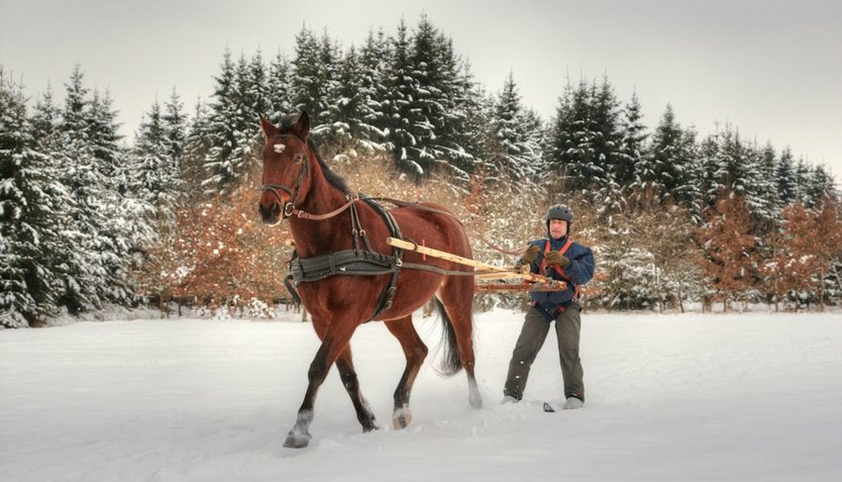
Credit:Edgar G Biehle/Shutterstock

Skijoring, a sport which requires being pulled by a horse whilst on skis, is undoubtedly winter’s craziest sport. A popular activity at western winter festivals, anyone with some courage can sign up for the skijoring obstacles course, which includes a set of jumps on a snowy track. If this sounds terrifying, fear not, watching the sport is equally thrilling and highly entertaining.

Bored at DIA? Take a tour of the airport's public art.
https://denverite.com/2021/11/22/bored-at-dia-take-a-tour-of-the-airports-public-art/

Vatican Museum
VATICAN CITY

Contemplate the artwork of the Vatican Museum by tuning into their website’s seven different virtual tours in high definition. Start with the frescoed vaulted ceilings of the Sistine Chapel, where Michelangelo spent the years between 1508 and 1512 painting scenes from the Old Testament. Recount the creation of the world with the Creation of Adam painting, see the tree of life in The Fall and Expulsion from Garden of Eden, and journey back to the destruction of Earth in Noah and the Flood. Work your way through the remainder of the Vatican museums and visit Raphael's Rooms, Pio Clementino Museum, Room of the Chiaroscuri, Chiaramonti Museum, New Wing, and Niccoline Chapel. These tours are compatible with WebVR, so pop visit one in your phone's browser, click the VR headset button, and pop your phone into a headset lik this one for a more immersive experience. And to visit the Vatican in real time, head over to their live stream, which also broadcasts the Pope’s daily mass.

Louvre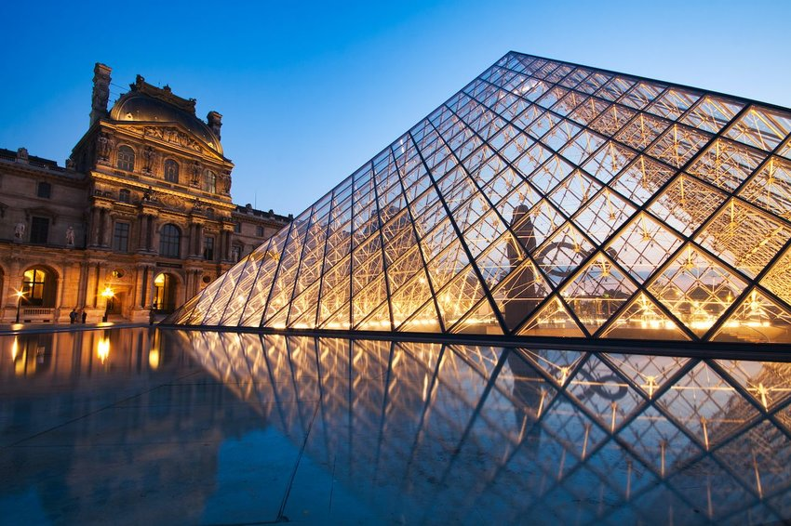
PARIS, FRANCE

Louvre | Photo: RomanSlavik.com
Transport yourself to the heart of Paris in the first arrondissement, and tour the Louvre, one of the world’s most admired art museums, visited by millions each year. It takes about three days to thoroughly tour every single room in the museum, but while it’s closed to visitors now, art lovers can continue to explore online. Offering virtual tours of three of their permanent exhibits on their website, you can discover ancient artifacts from the Pharaonic period in the Egyptian Antiquities tour, see the vaulted ceilings and French Crown Jewels in the the Galerie d’Apollon, and walk the moat that was built to protect this former fortress from attack in the Remains of the Louvre’s tour. Using the “Room Description” tab, you can also read about the remaining galleries with detailed descriptions, and envision the Mona Lisa in the Salle des Etats, and Théodore Géricault’s Raft of the Medusa in the Salle Mollien.

Returning From Grazing
In the evening, a nomad drives the herd home West Ujimqin, China

RANCHING BETWEEN ICE AND SKY IN PATAGONIA
Previous Slide
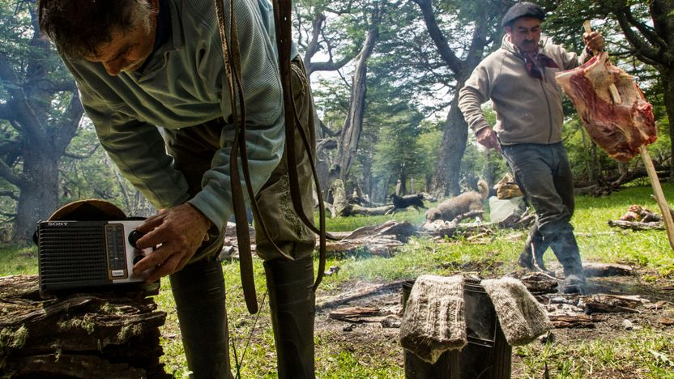

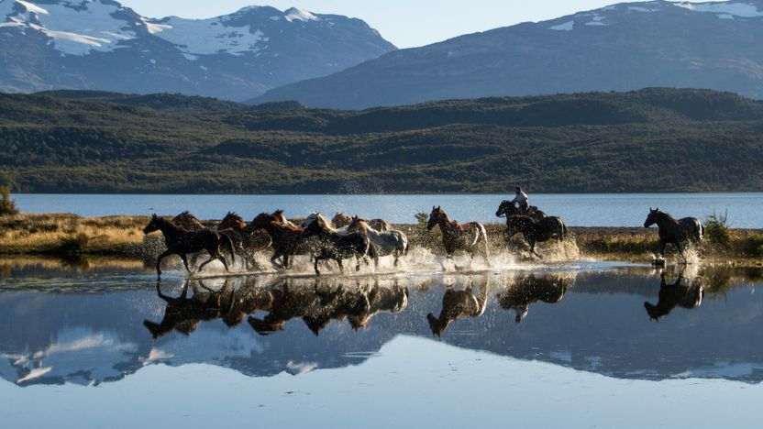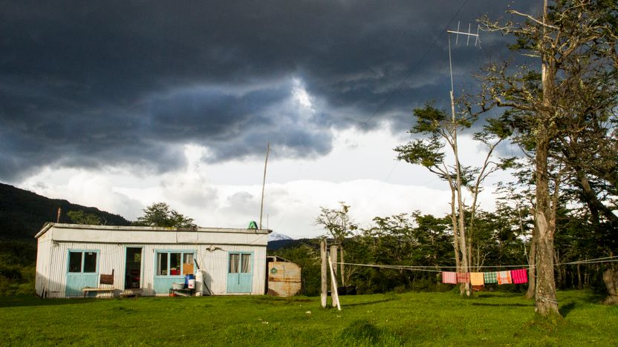

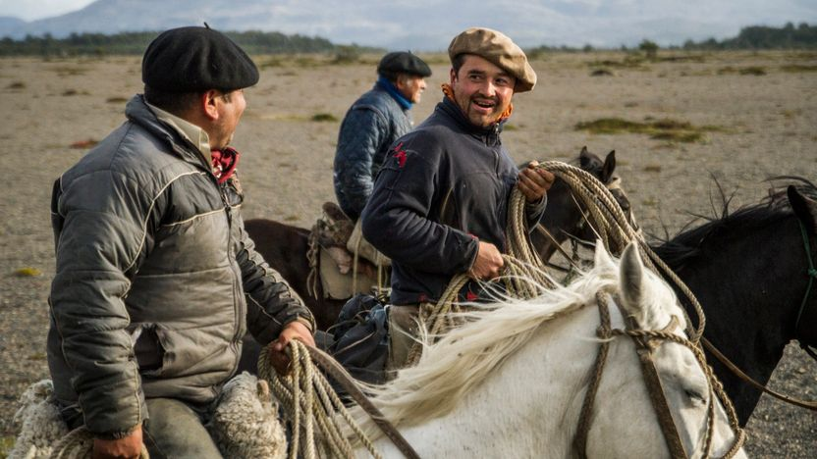
Breathing in fresh, dewy air and listening to the sound of your boots thump while stepping over branches, rocks, and leaves are reasons why a walk through the woods brings nature-lovers joy. A third of the Earth might be blanketed in forests, but we guarantee a visit to these places will make you feel like you’ve been transported to another dimension. These are the most beautiful forests in the world.

Dragon’s Blood Forest
SOCOTRA, Yemen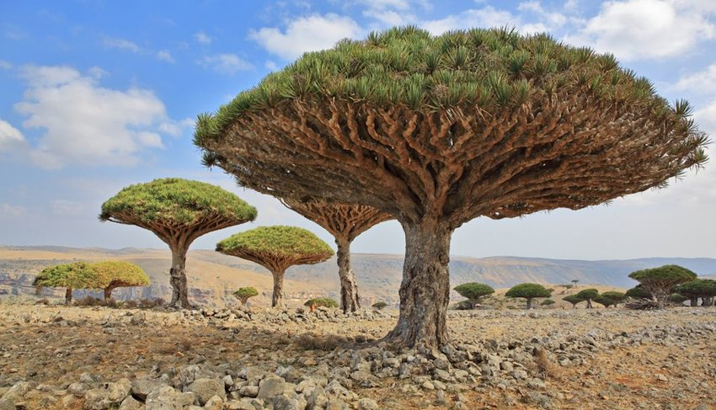

The remote archipelago of Socotra located 220 miles off the coast of Yemen is as exotic as it sounds. Known as the “Jewel of Arabia” and home to strange, umbrella-shaped dragon’s blood trees growing atop granite massifs, Socotra is a long-lost ecosystem frozen in time. The place has been thriving for millions of years in the Gulf of Aden and hundreds of unique species and organisms can't be found anywhere else on Earth. The undeveloped landscape with its lack of roads and infrastructure makes the journey throughout Socotra an adventure in itself. Only those with an innate desire to see something truly unique make the voyage.
“Anyone who considers protocol unimportant has never dealt with a cat.” Robert Heinline

Horse Troughs, Hot Tubs and Hashtags: Baptism Is Getting Wild by: Ruth Graham
In some evangelical churches, a once-staid ritual is returning to its informal roots — and things sometimes get “a little rowdy” along the way. Waves crashing over Paul Allen and Jimmy Scroggins of Family Church as they baptize a congregant in the Atlantic Ocean in Palm Beach, Fla. bracing themselves against the waves and keeping an eye out for sharks.
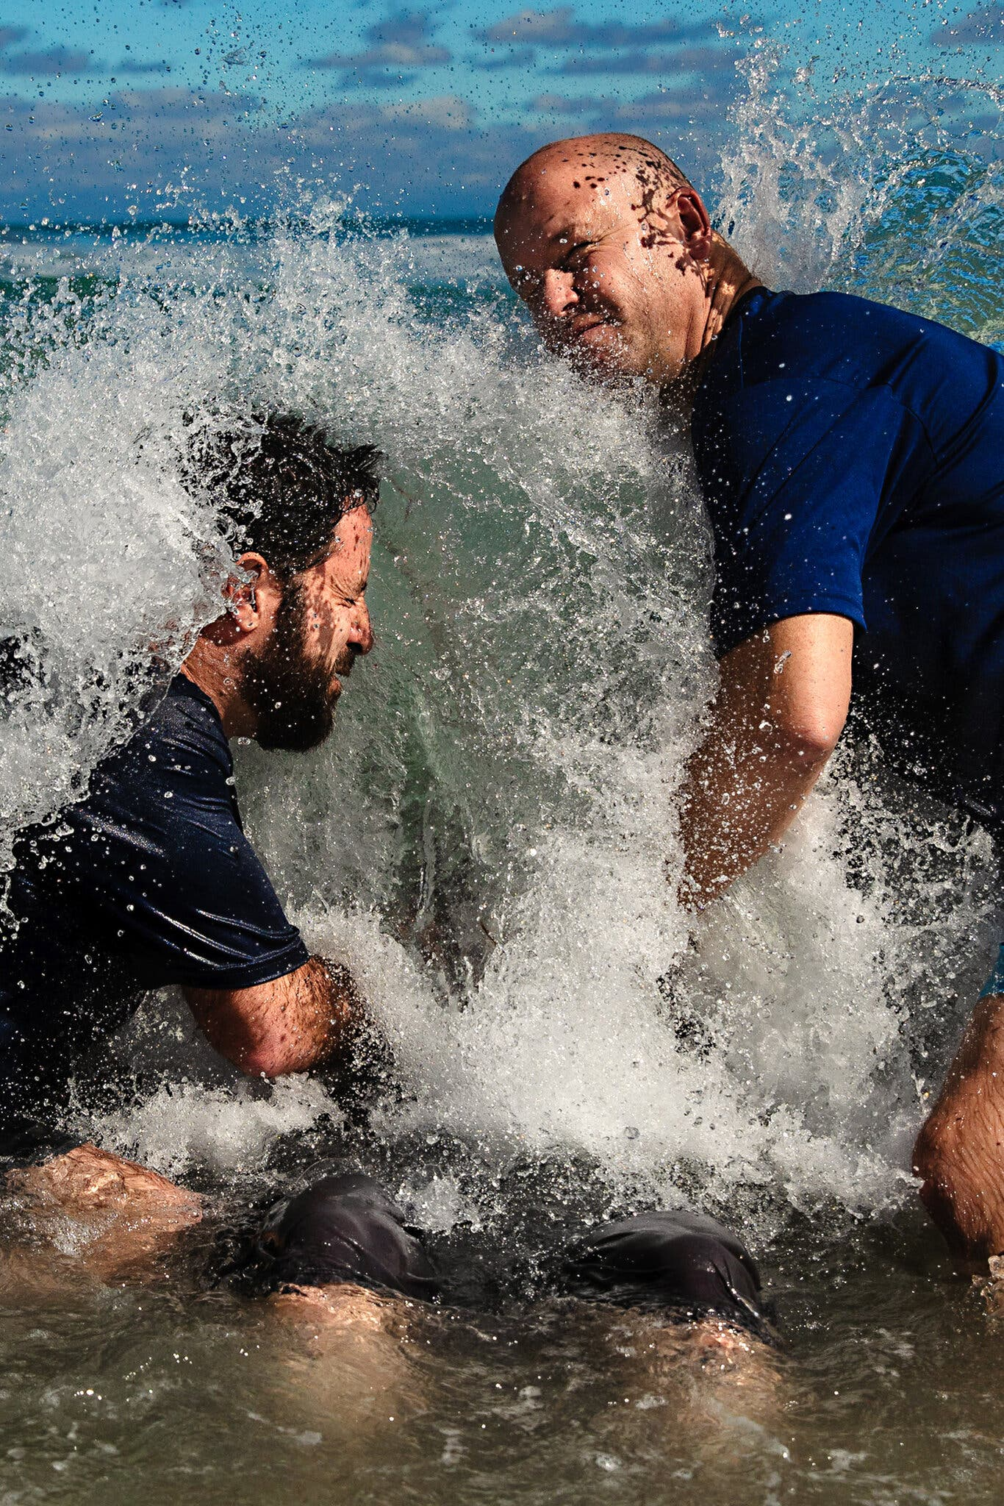

At Walk Church in Las Vegas, leaders set up a folding tub in the courtyard of the middle school that they use for Sunday services. In Mansfield, Texas, Creekwood Church rents out the Hawaiian Falls Waterpark, where twisting slides tower over the ceremony.

Our bishop, Karen Oliveto, shares with us her:
Vision for the Future of the United Methodist Church

11-20-2021 Inclusiveness 5 version 1.mp4

Open

