Something to Explore This Week
An Experiential Ministry By: Becky Lynch

Why Are So Few Flowers and Fruits Blue?
And More Questions From Our Smithsonian Readers

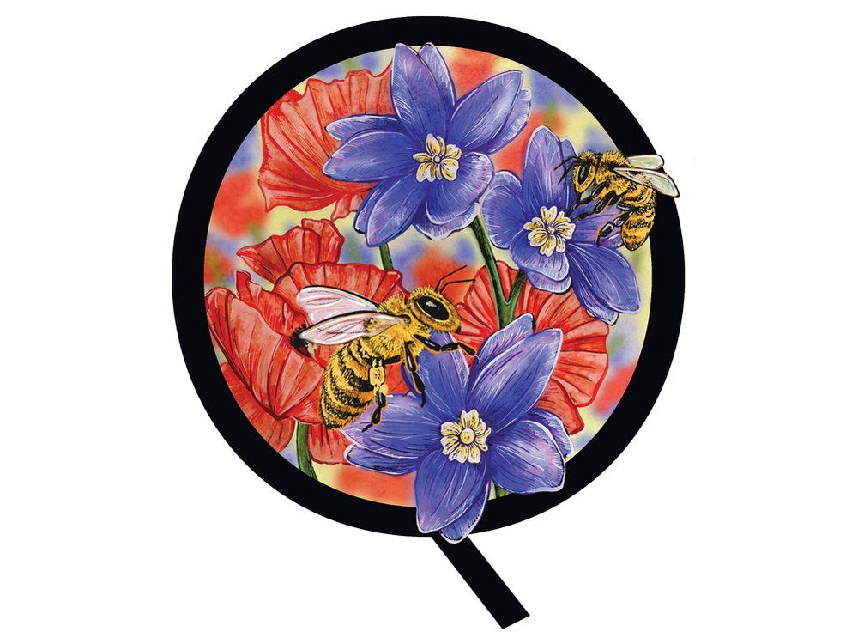
Q: Why are more fruits and flowers red, orange or yellow than blue?
—Robert L. Morrison | Poughkeepsie, New York
There is actually no true blue pigment in nature. A pigment creates color by absorbing certain wavelengths of light and reflecting others. Chlorophyll makes plants look green, carotene makes them look red or orange, and xanthophyll makes them look yellow. Plants make fruits and flowers look blue by shifting acidity levels, adding molecules or mixing pigments. Even then, it’s rare to see a blue plant with no reddish tint: A blueberry is slightly purple. So why do plants go blue? Most likely to attract specific pollinators—blue is highly visible to bees.
—Rose Gulledge, museum specialist, Department of Botany, National Museum of Natural History

Q: Why do military helicopters have Native American names?
—Eli Cash | New York City
The U.S. military began naming advanced weapons systems, as well as helicopters, after Native nations early in the second half of the 20th century. Ostensibly, it was done as a tribute to the valor and “warrior spirit” of Native Americans. However, it was done with neither the involvement nor agreement of tribes and many felt it perpetuated a simplistic 19th-century notion of Native Americans. Today, the military not only consults with Native groups and seeks their approval before using their names, but also in doing so acknowledges the many sacrifices and contributions Native Americans have made serving in the U.S. armed services.
—Cécile Ganteaume, co-curator of the “Americans” exhibition, National Museum of the American Indian
Q: How can sharks have such a high concentration of mercury and still be alive?
—Michael Anderson | Fort Kent, Maine
Mercury and other toxins are present in the blood and organs of not only sharks, but also other aquatic species. The concentration of such elements increases along the food chain, with those at the top having higher amounts than those at the bottom. Because many sharks are apex predators, they have especially high concentrations of mercury—they obtain it from their prey, which have obtained it from their own food sources. But despite the fact that sharks accumulate so much mercury, they seem to be immune to its harmful effects. Studies suggest that sharks have some physiological mechanism that protects them from mercury poisoning, but it’s not yet clear what that mechanism might be.
—Catalina Pimiento, research associate, Smithsonian Tropical Research Institute
It’s your turn to Ask Smithsonian.

Embrace the Thrill:

Go Horseback Riding on a Ranch
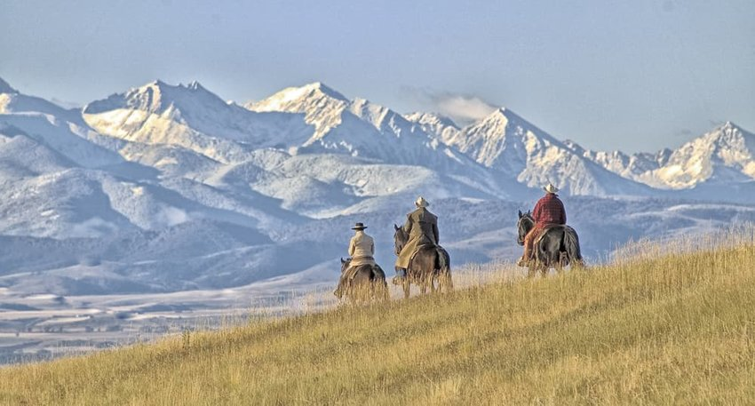
Credit: outdoorsman/Shutterstock
There’s nothing new about ranch holidays. City folk have been heading off on horseback riding adventures for more than a century. Get your spurs on and saddle up to go galloping through one of the country’s many cattle ranches. It doesn’t matter if you don't have any experience; many of the ranches teach horseback riding skills. Kick back at the end of the day with a hearty home-cooked ranch meal and a couple of well-deserved cold ones.

OR:
Search for Alligators in the Everglades
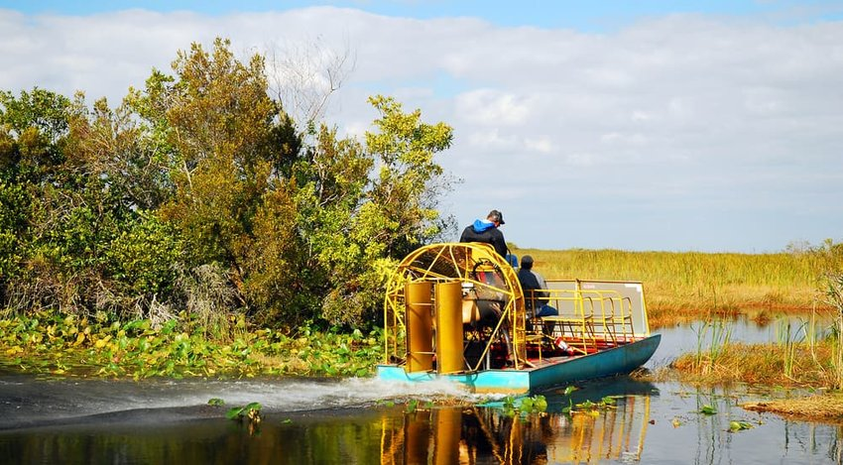
Credit: James Kirkikis/Shutterstock
Let’s get real. While the Florida Everglades teem with wildlife, there’s one beast that draws most people to the grassy mangroves. Is there anything more adrenaline-inducing than hurtling along the waterways perched atop an airboat in search of gators? Probably not. We’ve only got one piece of advice for you: don’t fall in.
The Bee Is Declared The Most Important Living Being On The Planet

Its sting hurts a lot, but if they were to disappear, it would hurt much more.The Earth Watch Institute concluded in the last debate of the Royal Geographical Society of London, that bees are the most important living being on the planet, however, scientists have also made an announcement: Bees have already entered into extinction risk.
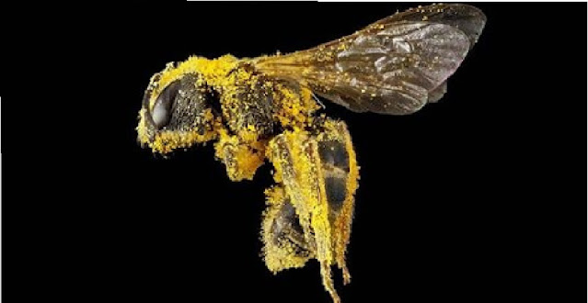

Bees around the world have disappeared up to 90% according to recent studies, the reasons are different depending on the region, but among the main reasons are massive deforestation, lack of safe places for nests, lack of flowers, use uncontrolled pesticides, changes in soil, among others.
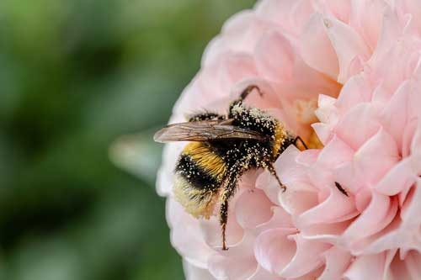
WHY HAVE BEES BEEN DECLARED AS THE MOST VALUABLE LIVING BEING ON OUR PLANET?
It was determined that bees are the only living being that is not a carrier of any type of pathogen, regardless of whether it is a fungus, a virus or a bacterium.

The agriculture of the world depends on 70% of these insects, to put it more clearly and directly, we could say that 70 of 100 foods are intervened in favor by bees.

Also the pollination that the bees make allows the plants to reproduce, of which millions of animals feed, without them, the fauna would soon begin to disappear.
The honey produced by bees, not only serve as food, but also provide many benefits to our health and our skin.

"According to a quote attributed to Albert Einstein, If the bees disappear, humans would have 4 years to live.”

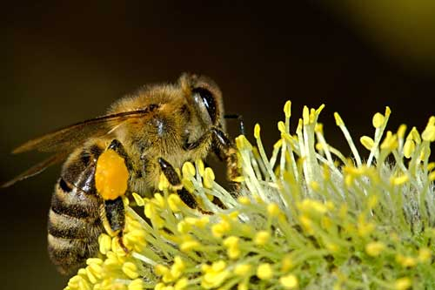
Quote for the day:

[Whatever] happens to other beings is happening to us… that leads to a new orientation in life where we live equally for ourselves and for others, and we are joyful and happy… Compassion makes you happy.
— Robert Thurman

Listen to this:

Have you ever felt like your Doctor just doesn’t “connect with you”?

Have you ever felt like you had no idea what made you “not prefer someone” you just met?

How would you like to cook your turkey in this?
One stove was called “Our Old Home.” Its fuel was coal or wood. It included a quite convenient feature. The roasting arrangement, shown below, made it easier for the cook to baste. Meat was suspended from a movable self-supporting rack which could be pulled out. A dripping pan, attached to a movable crane, was positioned below the rack and could also be pulled out. This allowed the cook to baste meat when it was outside of the oven. The meat could also be placed on or removed from the rack when outside of the oven.
The Ripple Effects of a Thank You

A new study shows that expressing gratitude affects not only the grateful person, but anyone who witnesses it.
Researchers studying gratitude have found that being thankful and expressing it to others is good for our health and happiness. Not only does it feel good, it also helps us build trust and closer bonds with the people around us.

These benefits have mostly been observed in a two-person exchange—someone saying thanks and someone receiving thanks. Now, a new study suggests that expressing gratitude not only improves one-on-one relationships, but could bring entire groups together—inspiring a desire to help and connect in people who simply witness an act of gratitude.
Gratitude Letter
Write a letter expressing thanks, and deliver it in person
Try It Now

These findings build on prior research by showing that expressions of gratitude not only provide social glue for the people involved—the grateful person and the benefactor—but also spread beyond the dyad, affecting witnesses in ways that could reverberate throughout a group.
“It’s easy to imagine how this might work in a workplace, where people are actually attending to and acknowledging other people’s good deeds and kindnesses,” says Algoe. “A whole group of people could be inspired to be kinder to one another, and, through this interwoven kindness, the group itself could become a higher-functioning group.”
Does this mean we should all be expressing gratitude more frequently? Yes, says Algoe—though how it’s expressed could differ by context and culture. For some situations, she says, it may be appropriate to be demonstrative rather than verbal—giving a hug, for example, or bringing a gift of flowers. In another context, a simple thank you—especially if it’s sincere and not manipulative—will get the ball rolling.
Julia Kabance, Oldest Known Woman Veteran of World War II, Dies at 111
She was also the oldest living member of the Prairie Band Potawatomi Nation
Livia Gershon

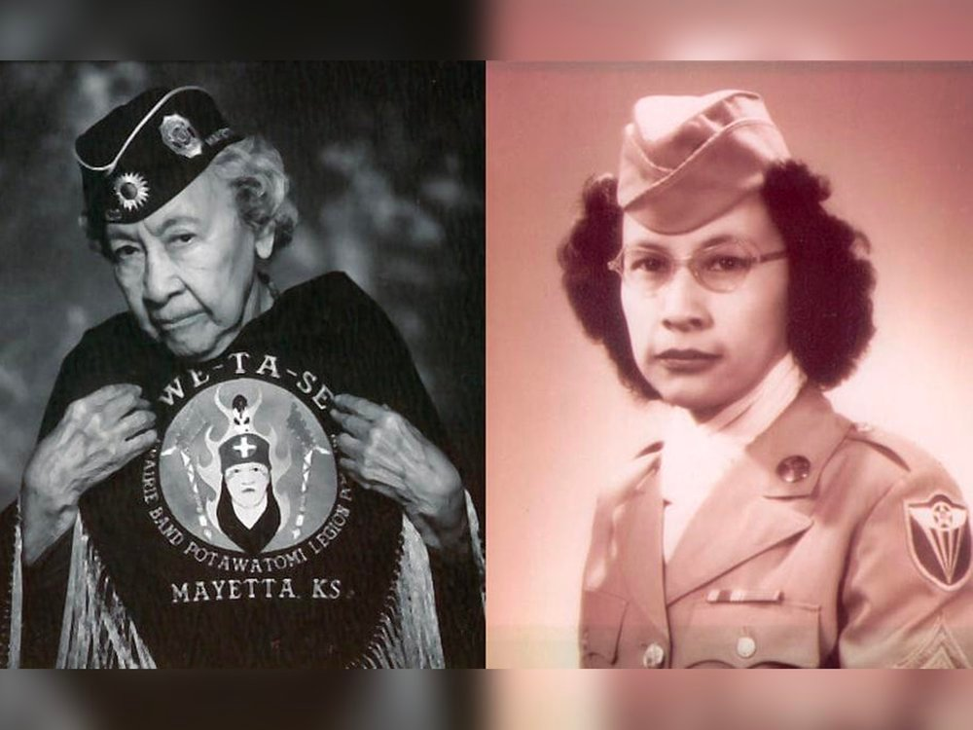
Kabance joined the Women's Army Corps in 1943. Courtesy of the Prairie Band Potawatomi Nation
Julia Kabance, who served during World War II as a member of the Women’s Army Corps (WAC), died last Tuesday at the age of 111. She was the oldest known woman veteran of the conflict and the oldest living citizen of the Prairie Band Potawatomi Nation.
“Julia was a proud member of the American Legion Post 410 We Ta Se, for her service in World War II,” Prairie Band Potawatomi Nation Chairman Joseph Rupnick tells Native News Online. “She was an inspiration to our tribe.”

