Something to Explore This Week: Christmas Trees
An Experiential Ministry By: Becky Lynch

John 3: 16. For God so loved the world, that he gave his only Son, that whoever believes in him should not perish but have eternal life.
For many cities, the annual tradition of putting up a Christmas tree is a treasured one. Many of them have a story behind them and all of them provide a little dash of joy to our lives as the nights draw in and the temperatures fall.
London, England
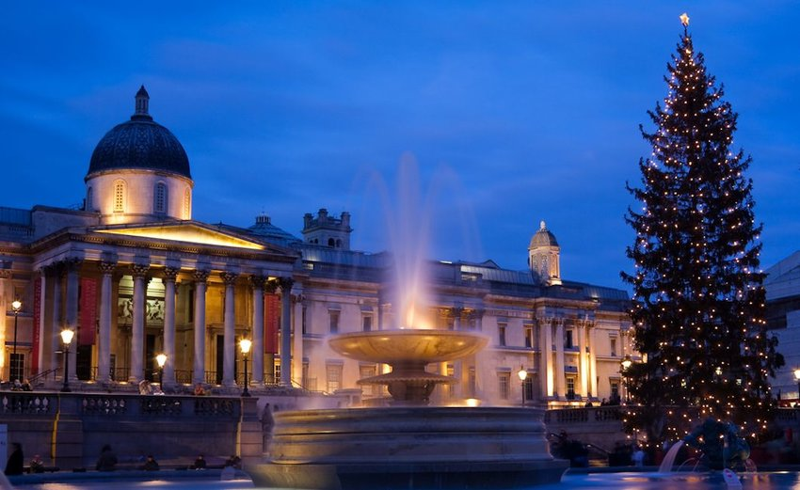
The tree that stands in Trafalgar Square is gifted each year from Oslo. Since 1947, a tree has symbolized the friendship between the two nations. It’s a token of their gratitude for the support shown by Britain during the Second World War, when the Norwegian government and its Royal family were forced into exile during the Nazi occupation. This year’s Norwegian spruce features vertical strings of lights, typical of the Scandinavian nation’s pared back style.

“Seeing is believing, but sometimes the most real things in the world are the things we can't see.” — "The Polar Express

New York City, United States
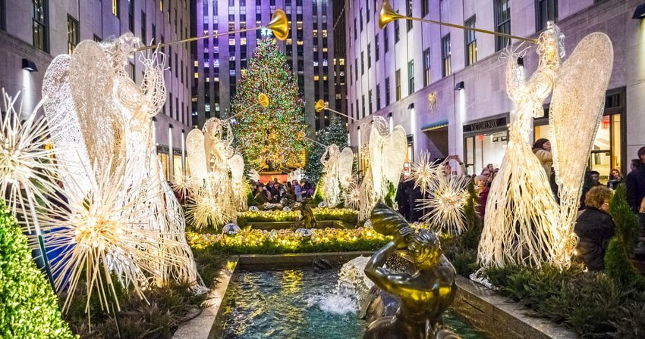
Credit: Andrew F Kazmierski/iStock

The iconic tree that stands in front of New York’s Rockefeller Center was originally designed as a pick-me-up for New Yorkers during the Great Depression in the 1930s. The first tree was erected on the site in 1931 by a bunch of local construction workers – two years later it would become an official city tradition. The ice rink followed in 1936. This year saw the 86th tree-lighting ceremony, and once the holiday’s over, the tree will be cut into lumber and donated to Habitat for Humanity, who’ll use it in home construction.

“Imagine what our real neighborhoods would be like if each of us offered, as a matter of course, just one kind word to another person.” Mr. Rogers

Tallinn, Estonia
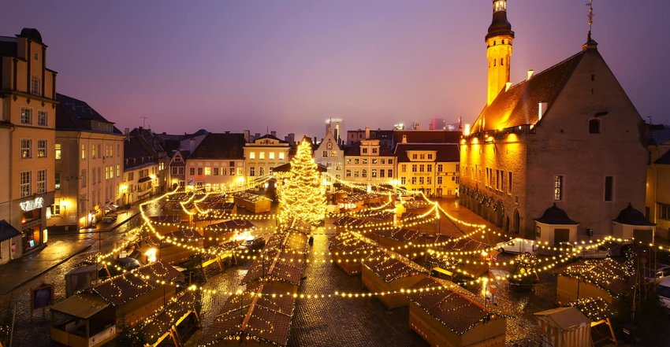
Credit: KavalenkavaVolha/iStock
The Estonian capital claims to have been the first in Europe to erect a municipal Christmas tree, though this is disputed by neighboring Latvia, which asserts that Riga’s predated it. Both cities tell the story of the Brotherhood of the Blackheads, a merchant association that donated a tree. Each year, the tree is installed with much ceremony, though never more so than in 1711 when Peter the Great, the Russian Emperor showed up to oversee the proceedings.

“When I despair, I remember that all through history the way of truth and love have always won. There have been tyrants and murderers, and for a time they can seem invincible, but in the end they always fail. Think of it — always.” Ghandi

Bethlehem, Palestine
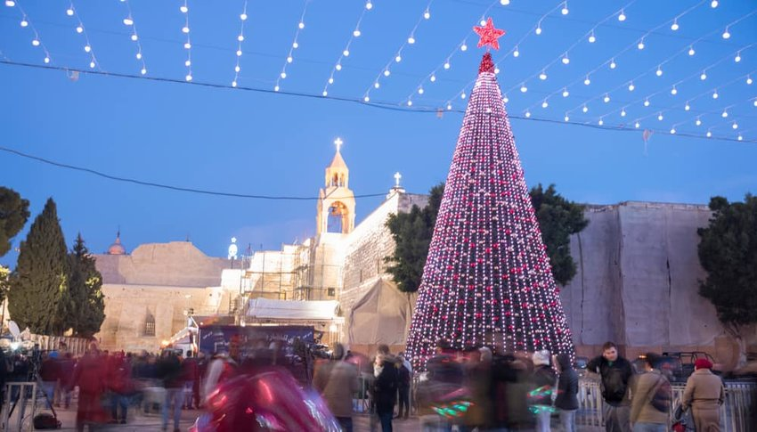
Credit: gary yim/Shutterstock
A Christmas tree is especially meaningful in Bethlehem, where it stands in Manger Square in front of the Church of the Nativity. Christians are a minority population here in the town commonly believed to be the birthplace of Jesus, though the town receives thousands of visitors in the run up to this important festival.

The Universal Declaration of Human Rights and the International Covenant on Civil and Political Rights. Article 18 of The Universal Declaration of Human Rights provides that “everyone has the right to freedom of thought, conscience and religion; this right includes freedom to change his religion or belief, and freedom, either alone or in community with others and in public or private, to manifest this religion or belief in teaching, practice, worship and observance.”

Paris, France
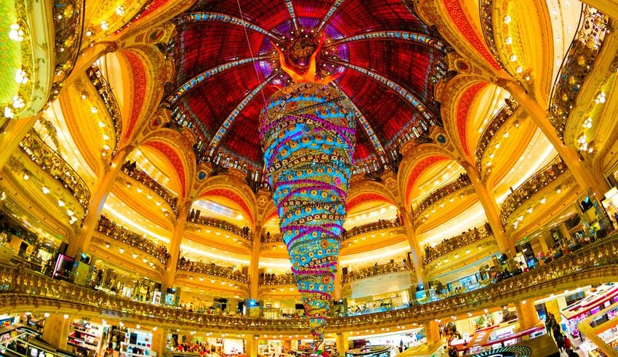
Credit: Felix Catana/Shutterstock
The window displays are delightful but it’s the tree inside the French capital’s most famous department store, Galeries Lafayette, that’s breathtaking. Each year, there’s a different theme – last year, it was the Dream Factory, sponsored by luxury watchmaker Piaget. In 2017, the opulent displays featured a tree made of balloons, thought by some to top the amazing upside-down tree that decorated the store a few years back.

“The path from dreams to success does exist. May you have the vision to find it, the courage to get on to it, and the perseverance to follow it.”
— Kalpana Chawla, NASA astronaut and first woman of Indian origin in space.

Rio de Janeiro, Brazil
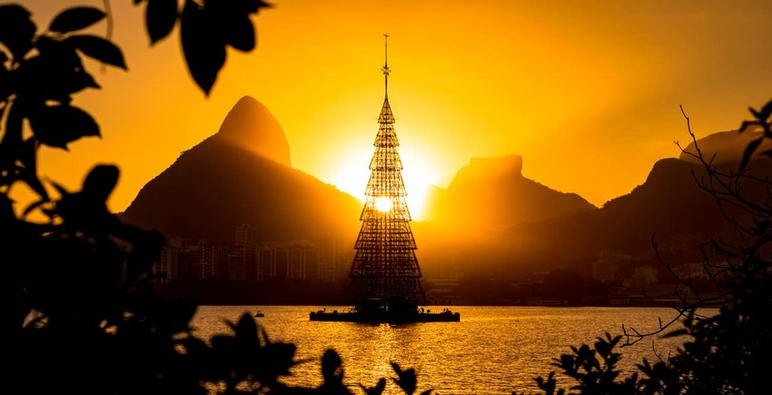
Rio’s Árvore de Natal da Lagoa returned last year after a two-year absence due to lack of sponsorship. That’s good news for Yuletide fans as it’s thought to be the world’s largest floating Christmas tree, occupying a prime spot in the Rodrigo de Freitas lagoon and lit with over 900000 LED bulbs. Thanks to the support of Petrobras, the 70-meter high tree was lit as part of a spectacular music and lights show.

Japanese Idiom:
井の中の蛙大海を知らず (I no naka no kawazu, taikai wo shirazu)
A frog in the well knows not the ocean.
This Japanese proverb is believed to have originated from a Chinese fable about a frog who spent his entire life in a well and who was then visited by a sea turtle from the ocean. The takeaway here is that we all have a limited view of the world, and that there is always, inevitably, more than we’re able to see or experience.

May God bless each of you and your families this Christmas Season

